Odoo Expenses

Contents

What are Expenses? 1

Creating Expense Products 1

Record a New Expense 2

Create the Expense Record 3

Attaching a Document 3

Validation by the manager 5

Control by Finance Department 5

Reimburse the employee 6

Expenses that are not reinvoiced to customers 6

Reinvoice expenses to customers 6

# What are Expenses?

Employee expenses are charges incurred on behalf of the company. If approved, the company then reimburses these expenses to the employee. In some cases, expenses can be charged to a customer.

The receipts encountered most frequently are:

* car travel, reimbursed per unit of distance (mile or kilometer),
* subsistence expenses, reimbursed based on the bill,
* other purchases, such as stationery and books, destined for the company but carried out by the employee.

# Creating Expense Products

Once these applications are installed you can configure the different products that represent the types of expenses. To create the firsts products, go to the menu **Configuration ‣ Expenses Products** in the **Expenses** application.

Some examples of products can be:

1. **Travel – Mileage**
   1. Product Type: Service
   2. Invoicing Policy: Invoice based on time and material
   3. Expense Invoice Policy: At sales price
   4. Sale Price: 0.54
   5. Unit of Measure: Km or Mile
2. **Travel – Rental Car**
   1. Product Type: Service
   2. Invoicing Policy: Invoice based on time and material
   3. Expense Invoice Policy: At cost
   4. Unit of Measure: Unit
3. **Travel – Airfare**
   1. Product Type: Service
   2. Invoicing Policy: Invoice based on time and material
   3. Expense Invoice Policy: At cost
   4. Unit of Measure: Unit
4. **Travel - Hotel**
   1. Product Type: Service
   2. Invoicing Policy: Invoice based on time and material
   3. Expense Invoice Policy: At cost
   4. Unit of Measure: Unit

In these examples, the first product will be an expense we reimburse to the employee based on the number of miles he did with his own car (e.g. to visit a customer): 0.54 / Mile. The hotel is reimbursed based on the real cost of the hotel.

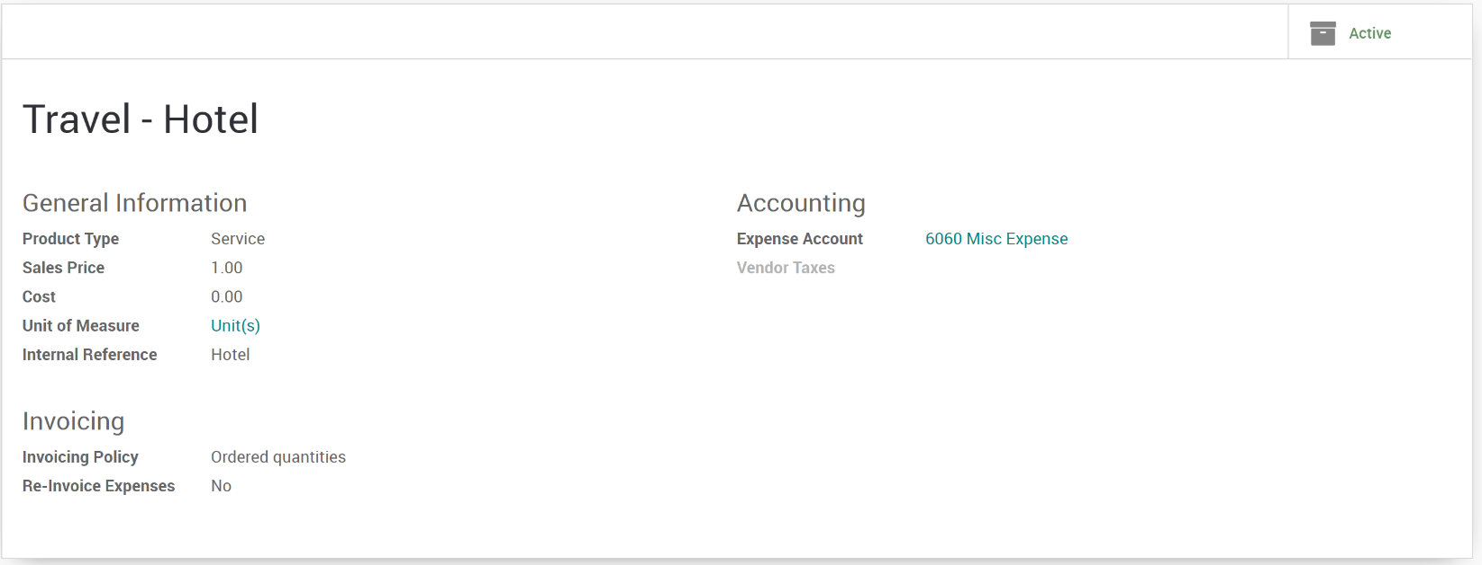

If the product is created outside of the expenses app, be sure that all these products have the checkbox **Can be expensed** checked and the invoicing policy set to **Invoice Based on time and material**. The Can be expensed is assumed if the product is created within the expense app. This invoicing policy means that, if the expense is related to a customer project/sale order, Odoo will re-invoice this expense to the customer.

Odoo support two types of expenses:

* expenses paid by employee with their own money
* expenses paid with a company credit card

# Record a New Expense

Every employee of the company can register their expenses from **Expenses App ‣ My Expenses**. The workflow for personal expenses works in the following way:

1. An employee record’s his expense and submits it to the manager.
2. The manager approves or refuses the expense.
3. The accountant post journal entries.
4. The company reimburse the employee expense (the employee is like a vendor, with a payable account).
5. If the expense is linked to an analytic account, the company can reinvoice the customer.

## Create the Expense Record

Once inside the expense app, click the create button to open a new expense record and fill in the required fields.

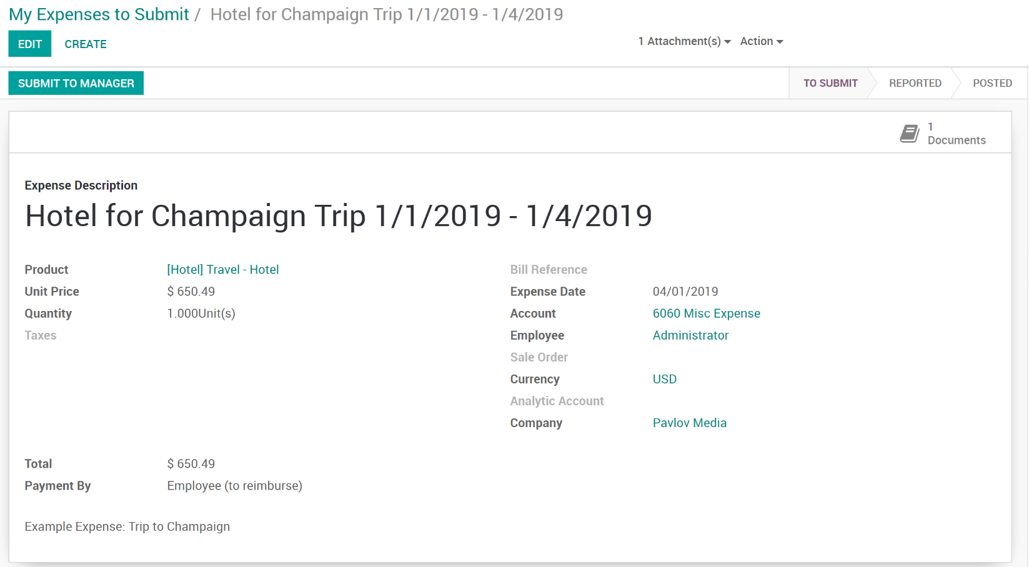

For every expense, the employee should record at least:

* **Description**: that should include the reference of the ticket / bill.
* **Product**: the expense type.
* **Price**: (e.g. hotel) or a quantity (e.g. reimburse km if travel with his own car)
* **Attached Document**: Scanned or photo of the receipt.

If the expense is linked to a customer sale or project, the employee should set an analytic account, related to the customer project or sale order.

## Attaching a Document

To attach a document, click on the Documents smart button to open the documents views related to the expense.

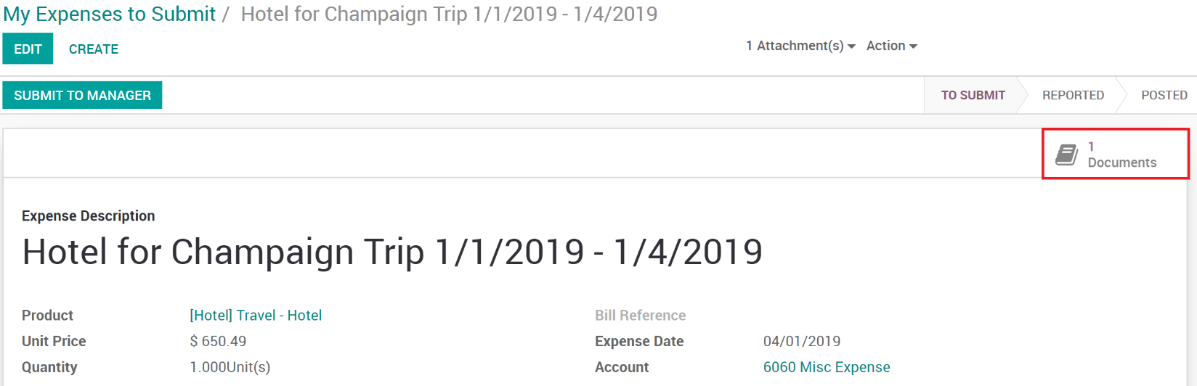

Click the create button to create and upload your document.

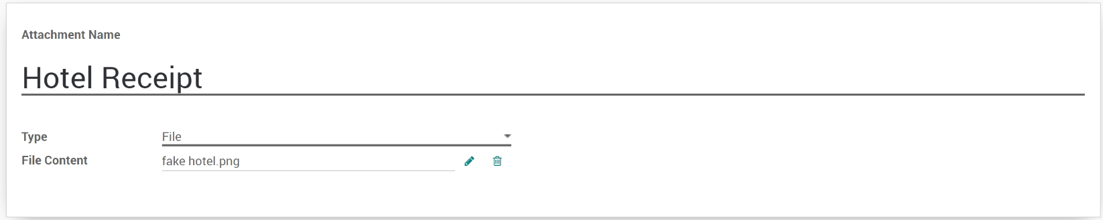

All documents will then show in the documents list and are accessible via the documents smart button.

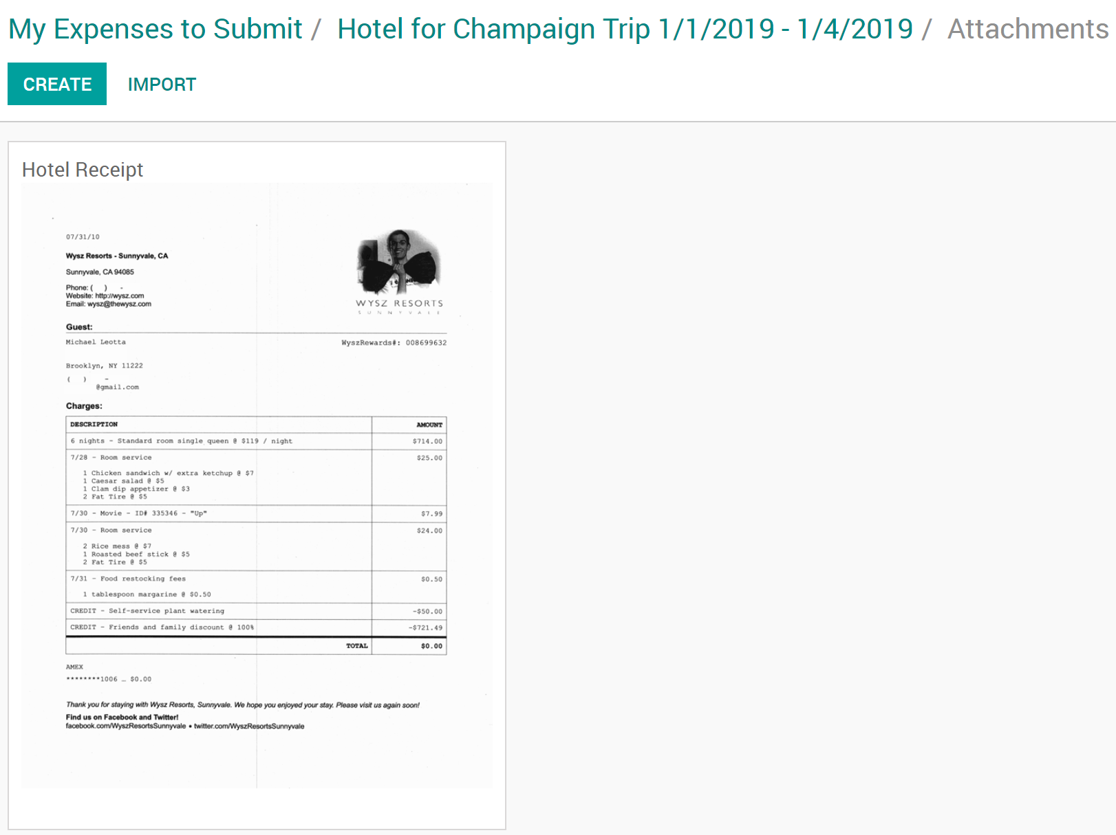

Once the expense is fully recorded, the employee will click the button **Submit to Manager**. This can be done at the time the expense record was created or in batch using the **Submit Expenses** action from the list view.

# Validation by the manager

Managers should receive an email for every expense to be approved (the manager of an employee is defined on the Employee App). They can use the menu **To Approve** to check all expenses that are waiting for validation.

The manager can:

* Discuss on an expense to ask for more information (e.g., if a scan of the bill is missing).
* Reject an expense.
* Approve an expense.

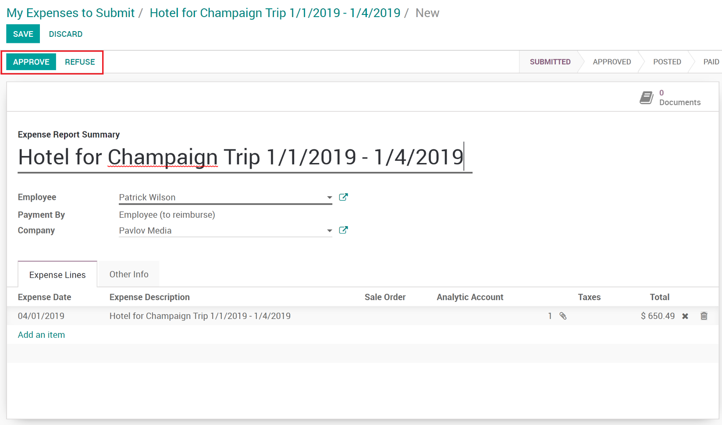

Once the expense has been approved by the manager, then it goes to the Finance department for further processing.

# Control by Finance Department

When all expenses that have been validated by the manager it is then reviewed again and posted by the accountant. When an expense is posted, the related journal entry is created and posted in the accounting.

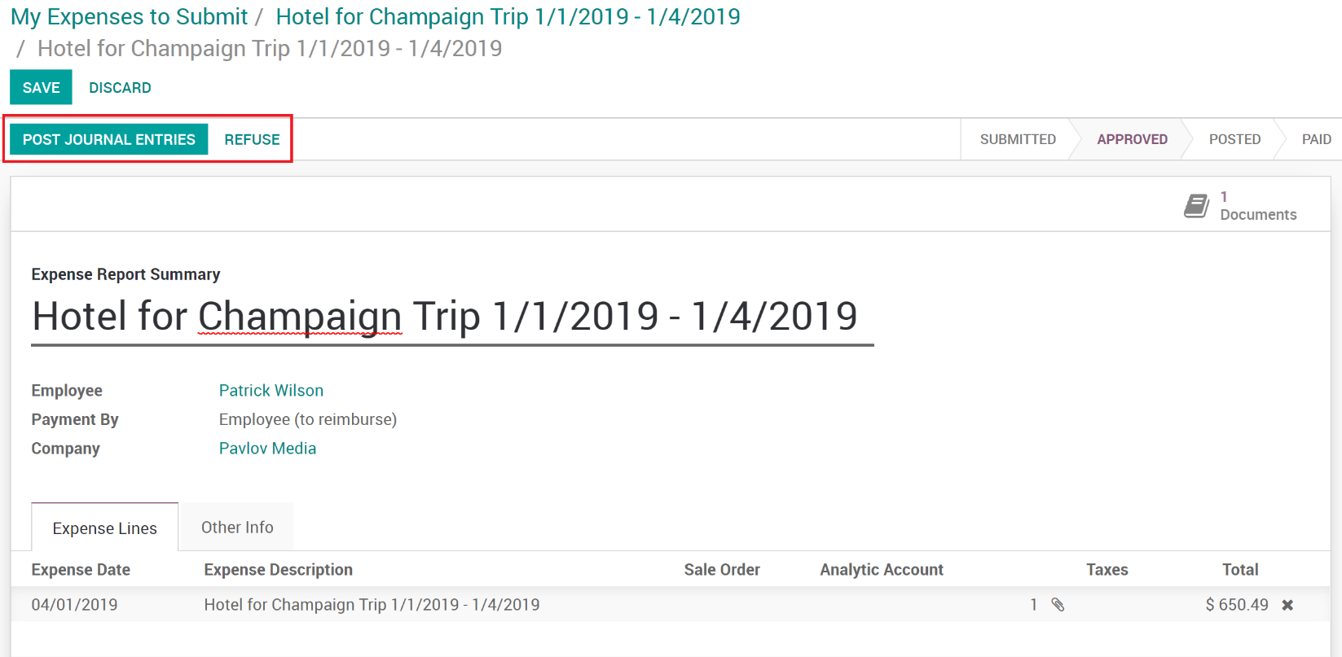

If the accountant wants to create only one journal entry for a batch of expenses, he can post expenses in batch from the list view of all expenses.

## Reimburse the employee

If the expense was paid with the employee's own money, the company should reimburse the employee. In such a case, the employee will appear in the aged payable balance until the company reimburse him his expenses.

The Accountant will need to create a payment to this employee for the amount due.

## Expenses that are not reinvoiced to customers

If some expenses should not be reinvoiced to customers, you have two options:

1. If the decision to invoice or not is related to the product, change the invoicing policy on the product:
   * **based on time and material**: reinvoice the customer.
   * **based on sale orders**: do not reinvoice the customer.
2. If there needs to be an exception for one invoice that should not be reinvoiced to the customer, do not set the related analytic account for this invoice.

## Reinvoice expenses to customers

If the expense was linked to an analytic account related to a sale order, the sale order has a new line related to the expense. This line is not invoiced to the customer yet and will be included in the next invoice that will be send to the customer (charge travel and accommodations on a customer project)

To invoice the customer, just click on the invoice button on his sale order. (or it will be done automatically at the end of the week/month if you invoice all your orders in batch)